Mountain Brook
Presbyterian Church

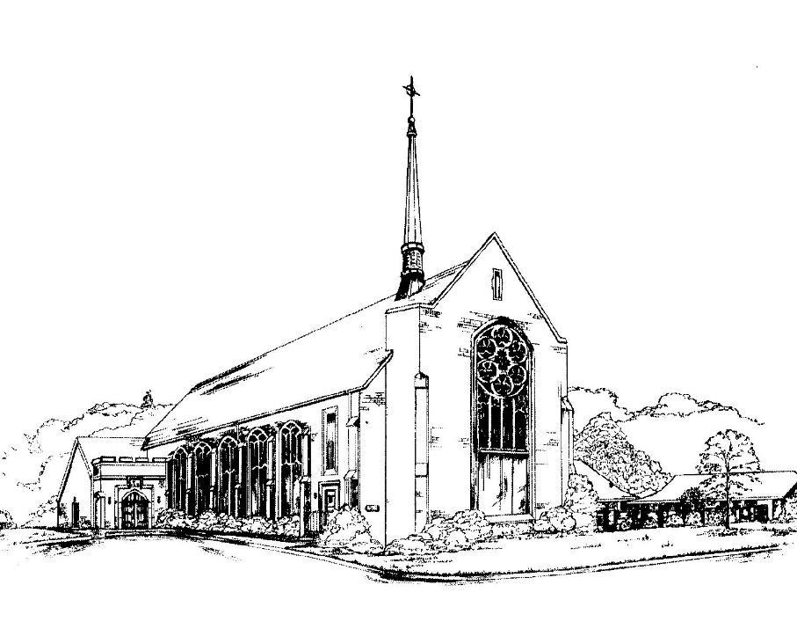
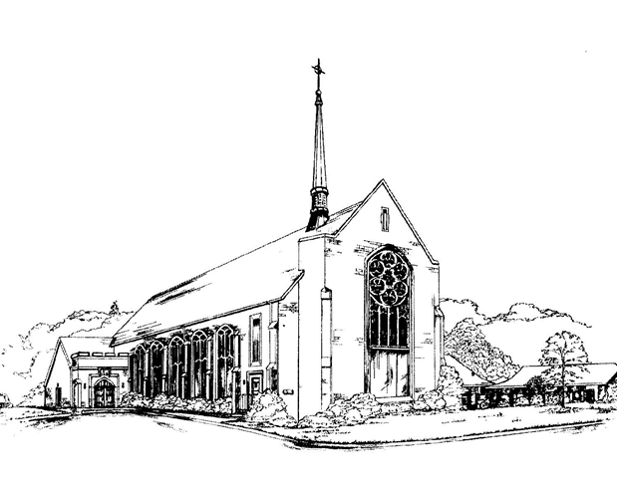

Living a Friendly Faith
“We love because God first loved us.” 1 John 4:19

December 5, 2021

3405 Brookwood Road • Mountain Brook, Alabama 35223
www. mbpcusa.org • (205) 967-5037

Prayer of Preparation

Gracious Lord,
our labors are in vain unless you labor with us, O God.
Continue to bless the work of our hands,
that we might labor for the glory of your name alone,
through your son Jesus Christ, in whose name we pray. Amen.

ORDER OF WORSHIP
December 5, 2021
✠ Gathering ✠

We gather to worship God. Come as you are, or put on your Sunday finest – whatever helps you worship in spirit and in truth.
Though many, and different, we are all one in Christ. Welcome.

(The service of worship begins with the music of the organ.
Through its power and brilliance may you feel the majesty and glory of God, and in its quietness, God’s peace.)

Prelude Savior to the Nations Come H. Walcha

Chiming of the Hour

*Introit Praise Ye the Lord of Hosts saint-saens

*Call to Worship Karen Ogle
Christ, the One who was, and is, and is to come,
welcomes you to this place.
As one body, with one voice,
we honor and glorify the giver of wisdom,
counsel, knowledge, and joy.
Amen.

*Advent Candle Lighting Adam Cobb & Family
Watch and wait for Christ’s coming!
Light candles of hope, peace, joy, and love,
remembering the promises of God with prayer.
We light this candle in hope.
We light this candle for peace.
Hear Zechariah’s song of hope for peace to the Christ child.

A reading from Luke 1:76-79:

“You, child, will be called the prophet of the Most High;
for you will go before the Lord to prepare his ways,
to give knowledge of salvation to his people
by the forgiveness of their sins.
By the tender mercy of our God,
the dawn from on high will break upon us,
to give light to those who sit in darkness
and in the shadow of death,
to guide our feet into the way of peace."

Let us pray:
God of hope, Prince of Peace,
You speak peace into the world
in the Way of the Christ child.
Help us embody your peace
and live as peacemakers
that we may be called children of God.
God of hope, God of peace,
into our darkness come.

*Hymn 106 Prepare the Way, O Zion BEREDEN VÄG FÖR HERRAN

Confession and Pardon
Call to Confession
Let us lay before God and one another the distances between us,
the impatience, idolatries, and lack of compassion
that form our confessions this day.
For if we say we have no sin, we deceive ourselves.
Yet in mercy, God will forgive us and renew us.

Confession of Sin
Gracious and welcoming God, have mercy on your people.
We do not live your word each day in all that we say and do.
We do not always love our neighbors, families, and friends
as beloved children whom you have made.
In your mercy, forgive us, for we repent of our ways
and look to your power to heal us and raise us up,
so that, at the last, you will gather us to you
and give us peace.

(A time of private confession)
Amen.

Declaration of Forgiveness
The reign of God has come near;
the repentant will be judged with righteousness.
You are forgiven. Be filled with hope,
believing in the power of the risen Christ
to bring you to new life. Rejoice and believe!

*Gloria (Hymn 113) Refrain: Angels We Have gloria
Heard on High
Gloria in excelsis Deo;
Gloria in excelsis Deo.

*The Peace
As the forgiven people of God,
let us greet one another in joy.
The peace of our Lord Jesus Christ be with you all.
And also with you.

Moment with Children Spencer Bissell
While the organist plays, children are invited to follow the crucifer to the chancel steps for the Children’s Moment. At the conclusion, the crucifer will lead the children back to their seats or to their classroom, as the case may be.

✠ The Word ✠

Prayer for Illumination Katherine Wellman
Your word, Holy God, was written for our instruction.
By your Holy Spirit open our ears
and fill us with the mysteries of your ancient love;
through Jesus Christ we pray. Amen.

1st Reading Malachi 3:1-4 (NRSV) Pew Bible, p. 830
¹See, I am sending my messenger to prepare the way before me, and the Lord whom you seek will suddenly come to his temple. The messenger of the covenant in whom you delight — indeed, he is coming, says the LORD of hosts. ²But who can endure the day of his coming, and who can stand when he appears?
For he is like a refiner's fire and like fullers' soap; ³he will sit as a refiner and purifier of silver, and he will purify the descendants of Levi and refine them like gold and silver, until they present offerings to the LORD in righteousness. ⁴Then the offering of Judah and Jerusalem will be pleasing to the LORD as in the days of old and as in former years.
Leader: The Word of the Lord. People: Thanks be to God.

Anthem Lo, How a Rose E’er Blooming M. Praetorius

2nd Reading Luke 3:1-6 (NRSV) Pew Bible, p. 890-91
¹In the fifteenth year of the reign of Emperor Tiberius, when Pontius Pilate was governor of Judea, and Herod was ruler of Galilee, and his brother Philip ruler of the region of Ituraea and Trachonitis, and Lysanias ruler of Abilene, ²during the high priesthood of Annas and Caiaphas, the word of God came to John son of Zechariah in the wilderness. ³He went into all the region around the Jordan, proclaiming a baptism of repentance for the forgiveness of sins, ⁴as it is written in the book of the words of the prophet Isaiah,
“The voice of one crying out in the wilderness:
‘Prepare the way of the Lord,
make his paths straight.
⁵Every valley shall be filled,
and every mountain and hill shall be made low,
and the crooked shall be made straight,
and the rough ways made smooth;
⁶and all flesh shall see the salvation of God.’”

Leader: The Word of the Lord. People: Thanks be to God.

Sermon The Messenger Rev. Roberts

✠ Response to the Word ✠

Baptism and Affirmation of Faith of Adam Cobb

Apostle’s Creed
I believe in God, the Father almighty,
Maker of heaven and earth,
and in Jesus Christ his only Son, our Lord;
who was conceived by the Holy Ghost,
born of the Virgin Mary,
suffered under Pontius Pilate,
was crucified, dead, and buried;
he descended to the dead;
the third day he rose again from the dead;
he ascended into heaven,
and sitteth on the right hand
of God the Father Almighty;
from thence he shall come to judge
the quick and the dead.
I believe in the Holy Ghost;
the holy catholic church;
the communion of saints;
the forgiveness of sins;
the resurrection of the body;
and the life everlasting. Amen.

Offering
We bear fruit worthy of our repentance when we give our tithes and offerings for the well-being of the poor.
Let us bear fruit as we joyfully give of our offerings.

Offertory Es ist ein Ros entsprungen J. Brahms

*Doxology old hundredth
Praise God, from whom all blessings flow;
Praise God all creatures here below;
Praise God above, ye heavenly host;
Praise Father, Son and Holy Ghost.

*Prayer of Dedication

✠ Eucharist ✠

*Hymn 88 O Come, O Come, Emmanuel veni emmanuel

Invitation to the Lord’s Table

The Great Prayer of Thanksgiving
The Lord be with you.
And also with you.
Lift up your hearts.
We lift them to the Lord.
Let us give thanks to the Lord our God.
It is right to give our thanks and praise.

Holy, Holy, Holy (Hymn 552)
Words Of Institution
Great is the mystery of faith:
Christ has died,
Christ is risen,
Christ will come again.

The Lord’s Prayer
Our Father, who art in heaven,
hallowed be thy name,
thy kingdom come, thy will be done,
on earth as it is in heaven.
Give us this day our daily bread;
and forgive us our debts, as we forgive our debtors;
and lead us not into temptation,
but deliver us from evil.
For thine is the kingdom, and the power,
and the glory, forever. Amen.

Communion of the People

Communion Anthem (Hymn 84) Creator of the Stars at Night conditor alme siderum

Prayer After Communion

✠ Sending ✠

*Hymn 132 Good Christian Friends, Rejoice in dulci jubilo

*Charge and Blessing
Benediction Response (Hymn 136) Go Tell It on The Mountain

Postlude O Come, O Come, Emmanuel arr. G. Smoke

* Please stand as you are able.
Childcare and Children
Childcare is provided for children, birth through age six, during worship. Children, preschool through third grade, are invited to participate in Sunday school during worship and they will leave the main worship service after the Children’s Moment.
On Sundays when the Lord’s Supper is offered, they will come back to the sanctuary for the Lord’s Supper. Older children are invited to remain in worship.

Acolytes: Rushton Robinson, Luke Kaiser, Jesse Horton

Announcements
- LUNCHEON TODAY! Join us for a seated lunch right after the service in the Fellowship Hall.
- CHRISTMAS PAGEANT and RECEPTION: Join us during service on December 19, as we enjoy a Christmas pageant presented by our youth, under the direction of Allison Sanders and Spencer Bissell. The service will be followed by a reception offering heavy hors-d'œuvres – all are welcome!
- CHRISTMAS EVE SERVICE: We would love to have you with us on Christmas Eve starting at 5PM as we celebrate Christ’s birth with singing and joyful worship.
- CHANCEL CHOIR: Wednesdays, from 6:45PM-8PM in the Reception Room.
- CHILDREN’S CHOIR: Wednesdays, from 5-6PM in the Choir Room. From now until the pageant on December 19, all children will be practicing for the pageant.

- WEDNESDAY NIGHT SUPPER: Join us for Wednesday Night Supper at 6:00PM in the Fellowship Hall. Prices: $10 for individuals; $20 for families. Childcare for toddlers and infants will be provided!

- SUNDAY SCHOOL: The whole family is invited to join us from 9:30-10:30 on Sunday mornings. Adults (and any interested middle schoolers and high schoolers) will meet in the Reception Room to discuss educational based studies of the Bible. Children, 1st grade and up, will meet with Spencer in the Toddler Room to learn more about the amazing stories in the Bible. Children, K-5 and younger, will meet with that week’s parent volunteer in the Infant Nursery.
- MAGIC CITY HARVEST DONTATIONS: The December donation item is Peanut Butter. The donation box is located inside the front entrance of the church.
The Staff
Pastor  Rev. Madison Roberts  Director of Music  Dewin Tibbs  Organist  Gary Smoke  Director of Christian Education  Spencer Bissell  Administrative Assistant  Sally Gregson | Director of Preschool  Molly Blackmon  Financial Assistant  Bernie Gregson  Boy Scout Troop 320  Scoutmaster: Dave Caskey  Cub Scout Pack 320  Cubmaster: Connie Caskey  Children’s Choir Director  Allison Sanders

The Session
The governing board of our church is called the “Session.” The current members of the Session are listed below. Please don’t hesitate to communicate with them about any matter concerning the church.

2022  Dave Kaiser  Norton Montague  Karen Ogle | 2023  Ralph Cook  Richard Edwards  Alan Speaker | 2024  Mindy Faircloth  Alex Wellman  Judy Wilson

Please access the church website at www.mbpcusa.org
to view the church calendar and video of portions of our weekly services.

Please take your bulletin home and refer to it during the week, or recycle it in the basket provided in the narthex.

Permission to reprint/stream the music in this service is obtained from ONE LICENSE with license #A-726770. All Rights Reserved.

