Mountain Brook
Presbyterian Church

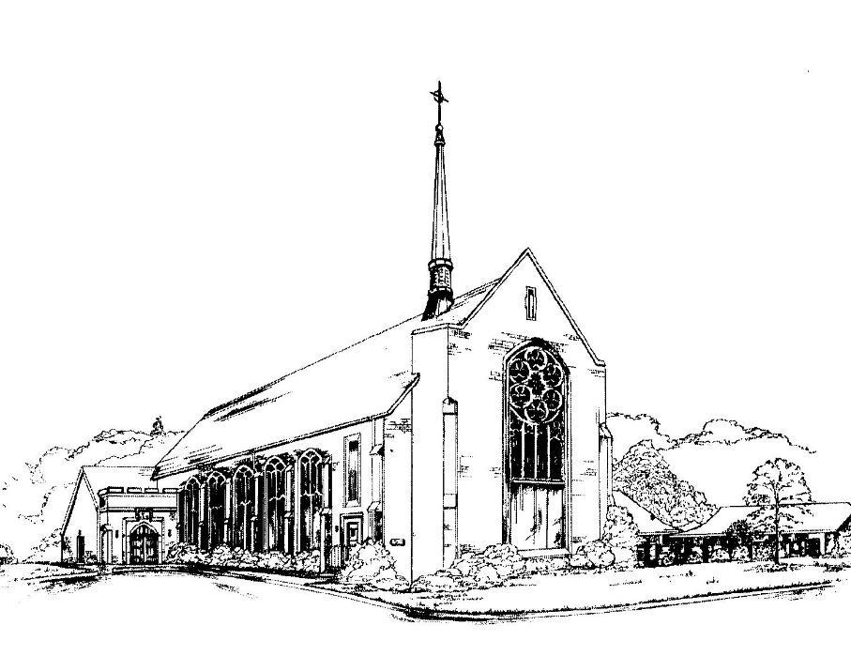
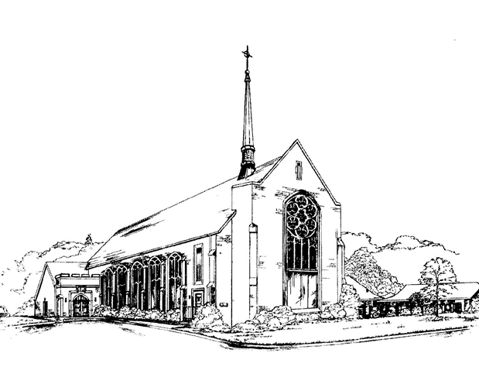

Living a Friendly Faith
“We love because God first loved us.” 1 John 4:19

January 16, 2022

3405 Brookwood Road • Mountain Brook, Alabama 35223
www. mbpcusa.org • (205) 967-5037

Prayer of Preparation

Holy God,
through signs of grace you reveal your glory to all the world.
Open our eyes to the hidden and surprising wonders you perform,
that we may believe with our minds and trust in our hearts
that you alone are Lord of all creation.
Though Christ, in the power of the Holy Spirit, we pray. Amen.

ORDER OF WORSHIP
January 16, 2022
✠ Gathering ✠

We gather to worship God. Come as you are, or put on your Sunday finest – whatever helps you worship in spirit and in truth.
Though many, and different, we are all one in Christ. Welcome.

(The service of worship begins with the music of the organ.
Through its power and brilliance may you feel the majesty and glory of God, and in its quietness, God’s peace.)

Prelude Andante H. Schroeder
(1904-1984)

Chiming of the Hour

*Introit (Hymn 655) What Shall I Render to the Lord martydom

*Call to Worship Karen Ogle

*Hymn 12 Immortal, Invisible, God Only Wise st. denio

* Please stand as you are able.
Confession and Pardon

Call to Confession

Confession of Sin

Almighty God, we confess that we have been led astray
by the idols of our world.
We have depended on our possessions
and have not placed our trust in your grace.
We have carelessly consumed the gifts you offer
and have failed to be faithful stewards
of the earth’s resources.
We have sought security in the might of the sword
rather than the strength of your Holy Spirit.
Forgive us, we pray.
Lead us to true repentance that we may serve you faithfully.

(A time of private confession)
Amen.

Declaration of Forgiveness

*Gloria (Hymn 583) Glory to God gloria (taizé)

*The Peace
As the forgiven people of God, let us greet one another in joy.
The peace of our Lord Jesus Christ be with you all.
And also with you.
Moment with Children Spencer Bissell
While the organist plays, children are invited to follow the crucifer to the chancel steps for the Children’s Moment. At the conclusion, the crucifer will lead the children back to their seats or to their classroom, as the case may be.

✠ The Word ✠

Prayer for Illumination Rushton Robinson

1st Reading Psalm 36:5-10 (NRSV) Pew Bible, p. 483

⁵Your steadfast love, O LORD, extends to the heavens,
your faithfulness to the clouds.
⁶Your righteousness is like the mighty mountains,
your judgments are like the great deep;
you save humans and animals alike, O LORD.
⁷How precious is your steadfast love, O God!
All people may take refuge in the shadow of your wings.
⁸They feast on the abundance of your house,
and you give them drink from the river of your delights.
⁹For with you is the fountain of life; in your light we see light.
¹⁰O continue your steadfast love to those who know you,
and your salvation to the upright of heart!

Leader: The Word of the Lord. People: Thanks be to God.

Anthem Simple Song Leonard Bernstein Bob Marston, tenor (1918-1990)

2nd Reading John 2:1-11 (NRSV) Pew Bible, p. 923

¹On the third day there was a wedding in Cana of Galilee,
and the mother of Jesus was there.
²Jesus and his disciples had also been invited to the wedding.
³When the wine gave out, the mother of Jesus said to him,
“They have no wine.”
⁴And Jesus said to her,
“Woman, what concern is that to you and to me?
My hour has not yet come”
⁵His mother said to the servants,
“Do whatever he tells you.”
⁶Now standing there were six stone water jars for the Jewish rites of purification, each holding twenty or thirty gallons.
⁷Jesus said to them, “Fill the jars with water.”
And they filled them up to the brim.
⁸He said to them, “Now draw some out,
and take it to the chief steward.” So they took it.
⁹When the steward tasted the water that had become wine,
and did not know where it came from (though the servants who had drawn the water knew), the steward called the bridegroom
¹⁰and said to him, “Everyone serves the good wine first,
and then the inferior wine after the guests have become drunk.
But you have kept the good wine until now.”
¹¹Jesus did this, the first of his signs, in Cana of Galilee,
and revealed his glory; and his disciples believed in him.

Leader: The Word of the Lord. People: Thanks be to God.

Sermon He Turned the Water into Wine Rev. Roberts

*Hymn 440 Jesus, Lover of My Soul ABERYSTWYTH

✠ Response to the Word ✠

Affirmation of Faith Apostle’s Creed

I believe in God, the Father almighty,
Maker of heaven and earth,
and in Jesus Christ his only Son, our Lord;
who was conceived by the Holy Ghost,
born of the Virgin Mary,
suffered under Pontius Pilate,
was crucified, dead, and buried;
he descended to the dead;
the third day he rose again from the dead;
he ascended into heaven,
and sitteth on the right hand
of God the Father Almighty;
from thence he shall come to judge
the quick and the dead.
I believe in the Holy Ghost;
the holy catholic church;
the communion of saints;
the forgiveness of sins;
the resurrection of the body;
and the life everlasting. Amen.

Announcements

Prayers for the People

The Lord’s Prayer

Our Father, who art in heaven, hallowed be thy name,
thy kingdom come, thy will be done,
on earth as it is in heaven.
Give us this day our daily bread;
and forgive us our debts, as we forgive our debtors;
and lead us not into temptation, but deliver us from evil.
For thine is the kingdom, and the power,
and the glory, forever. Amen.

Offering
Offertory In the Garden arr. G. Smoke

*Doxology old hundredth
Praise God, from whom all blessings flow;
Praise God all creatures here below;
Praise God above, ye heavenly host;
Praise Father, Son and Holy Ghost.

*Prayer of Dedication

✠ Sending ✠
*Hymn 475 Come, Thou Fount of Every Blessing nettleton

*Charge and Blessing

Benediction Response (Hymn 435)
There’s A Wideness in God’s Mercy in babilone

Postlude Ricercar A. Gabrieli (1533-1585)
Childcare and Children
Childcare is provided for children, birth through age six, during worship. Children, preschool through third grade, are invited to participate in Sunday school during worship and they will leave the main worship service after the Children’s Moment.
On Sundays when the Lord’s Supper is offered, they will come back to the sanctuary for the Lord’s Supper. Older children are invited to remain in worship.

Acolytes: Tripp Robinson, Jackson Robinson, Emily Kim

Announcements
- MAGIC CITY HARVEST DONATIONS: The January donation item is tuna fish. The donation box is located inside the front entrance of the church.

- CHANCEL GUILD MEETING: The Chancel Guild will meet on Monday, January 24 at 10AM in the Reception Room.

- DRAWER BUILD: Next Sunday, January 23, at 2:00PM. Come help put together drawers that will be used to make chests of drawers for the Presbyterian Home for Children’s on campus housing units that will provide temporary housing to at-need children and their female caregivers. We will meet outside the Scout Hut.

- CONFIRMATION CLASSES: MBPC’s Confirmation Class will be on held Monday nights from 6:30PM – 8:00PM beginning on February 7. The class is open to 7th-12th grade students.

- SCOUT SUNDAY: February 13th during 11:00AM Worship.

The Staff
Pastor  Rev. Madison Roberts  Director of Music  Dewin Tibbs  Organist  Gary Smoke  Director of Christian Education  Spencer Bissell  Administrative Assistant  Sally Gregson | Director of Preschool  Molly Blackmon  Financial Assistant  Bernie Gregson  Boy Scout Troop 320  Scoutmaster: Dave Caskey  Cub Scout Pack 320  Cubmaster: Connie Caskey  Director of Children’s Music  Allison Sanders
The Session
The governing board of our church is called the “Session.” The current members of the Session are listed below. Please don’t hesitate to communicate with them about any matter concerning the church.

2022  Dave Kaiser  Norton Montague  Karen Ogle | 2023  Ralph Cook  Richard Edwards  Alan Speaker | 2024  Mindy Faircloth  Alex Wellman  Judy Wilson

Please access the church website at www.mbpcusa.org
to view the church calendar and video of portions of our weekly services.

Please take your bulletin home and refer to it during the week, or recycle it in the basket provided in the narthex.

Permission to reprint/stream the music in this service is obtained from ONE LICENSE with license #A-726770. All Rights Reserved.

